TEAM ID :PNT2022TMID45578

BATCH:B3 - 3M5E

PROJECT NAME :Car Resale Value Prediction

RAJESHWARI R CLOUD ACCOUNT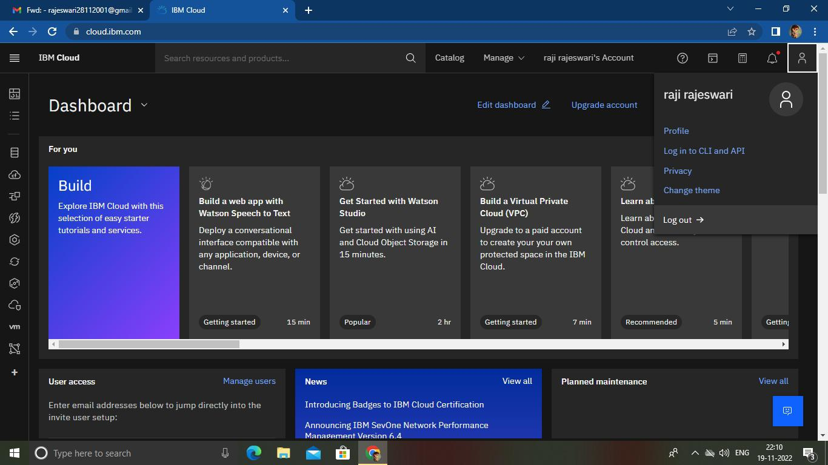

GOWSHE A CLOUD ACCOUNT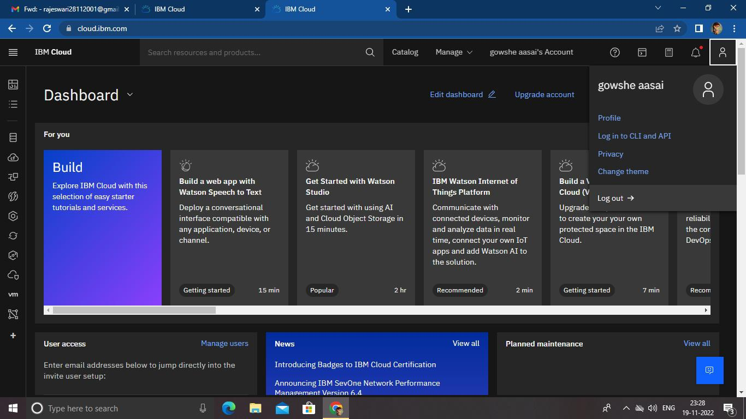

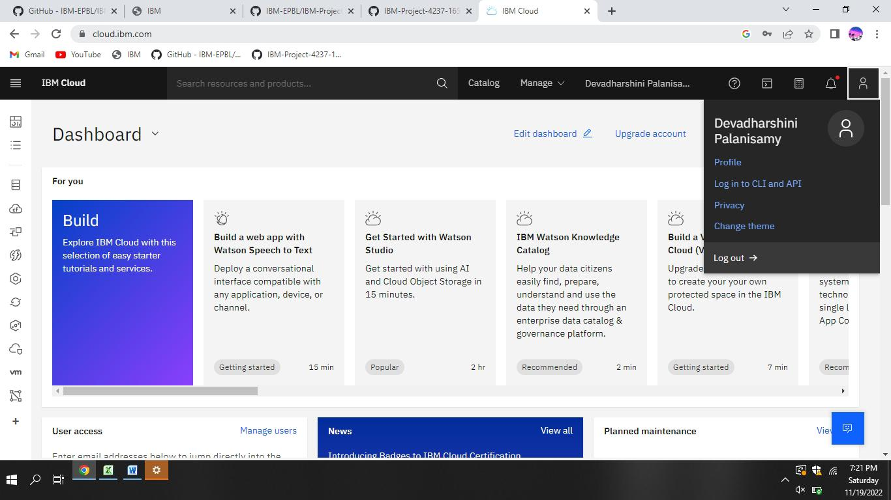DEVADHARSHINI P CLOUD ACCOUNT

DURGA G CLOUD ACCOUNT

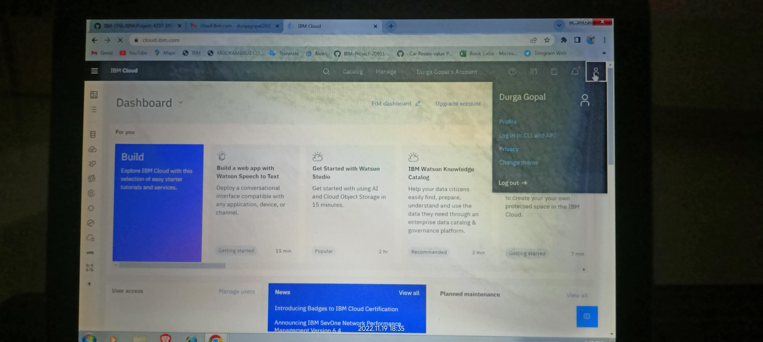

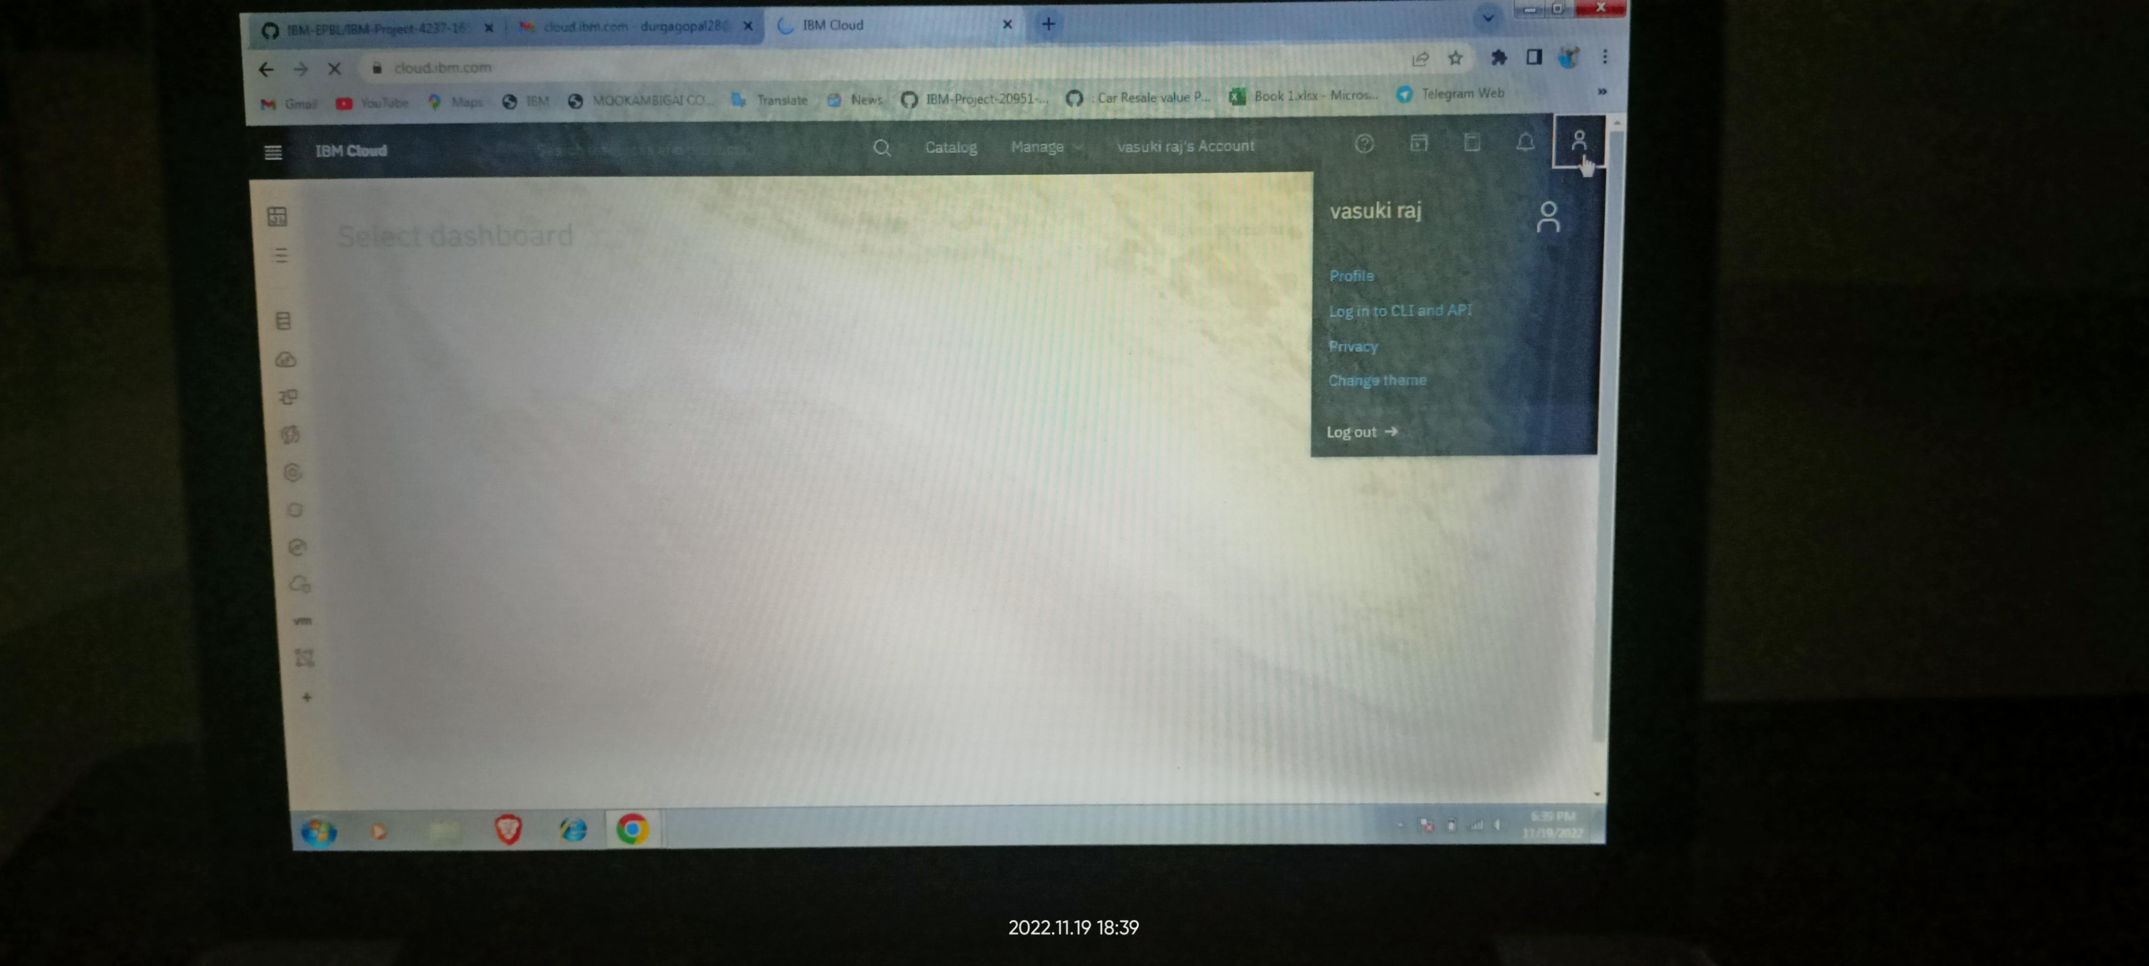VASUKI R CLOUD ACCOUNT